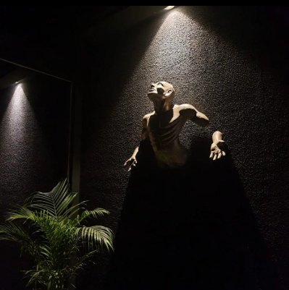

The things I could've been,
Things I let go of,
for no reason, no vision,
just an aversion, towards submission ,

Things that are happy,
Things that are to be enjoyed,
Things that make us, us,
Things that now I wish,
I could've been,

whom do I have to blame,
if not me,
but tell me how could I fight,
everything and everyone,
It has been my losses,
my not being good enough,
my putting up a pretense,
that I am who I think I am,

what if I'm not?
what if I was just you,
hanging by a thread,
what If I'm more you,
than you realize you are,

what If I get more lost,
everytime you think,
I've found myself,
what if I say I've,
never had a home,
that I'm tired of moving on,

what if I say,
I've never found rest,
not when I sleep, not when,
I try not to think,
not when I sit,
by your side,
not when I've
tried not to breathe ,
not when I've shut myself off,
not when I've worn my heart on
my sleeve,

from one home to another,
from one thought to another,
from one heart to another,
from one dream to another,
from one loss to another,
from one win to another,
from one me, to another,

I've always moved on,

I don't want to,
let me rest.

